Site url : dev.aflix.tv

# Detailed Reporting

Login as admin

<http://dev.aflix.tv/admin>

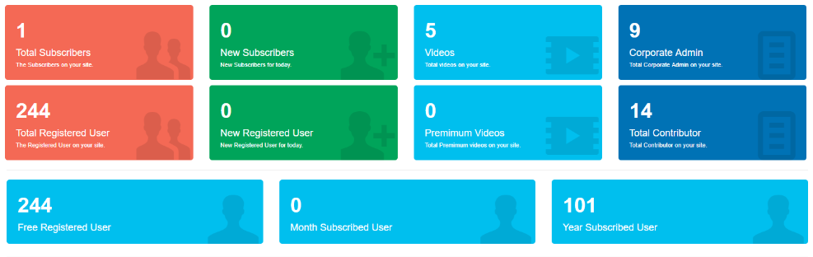

url

<http://dev.aflix.tv/admin/viewershipdashboard>

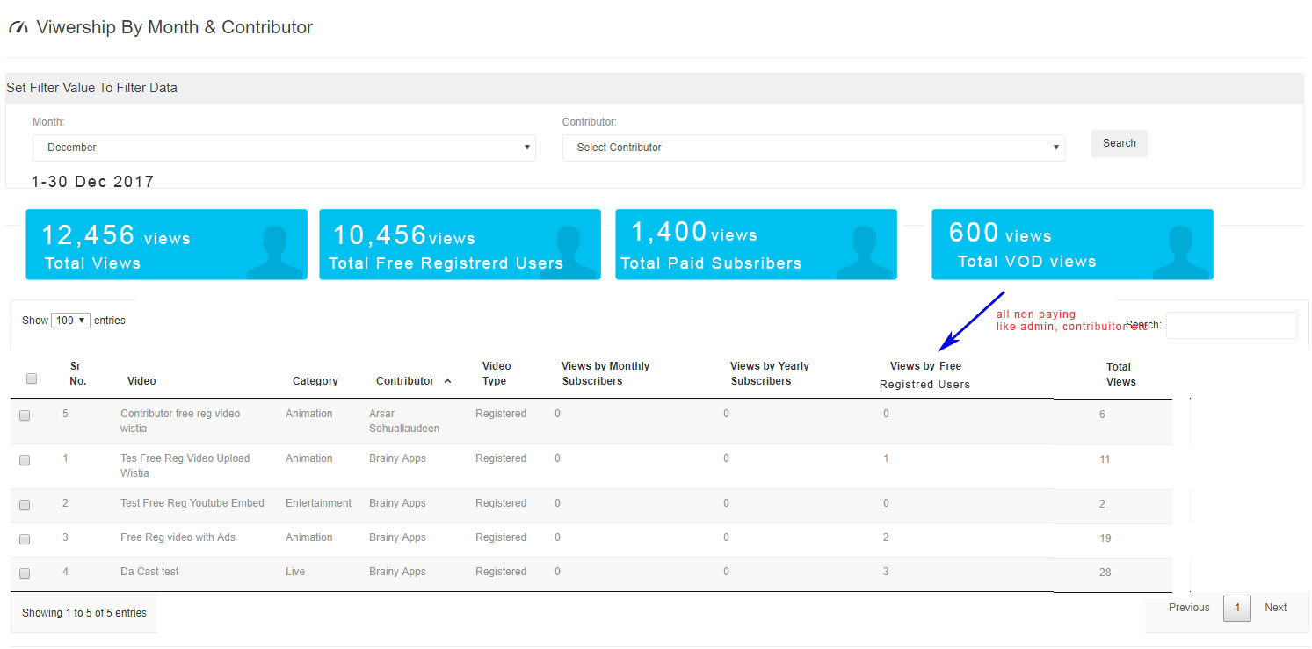

When login as contributor, should only be filtered by his own videos

Total views must tally with the distributed views

url

<http://dev.aflix.tv/admin/trackrevenue>

Revenue must be able to calculated automatically, its eixst there, mush double chec

Default calculations are as follows

This is how the revenue works, need to show the following on the above dashboard format

Following table describes how revenue will work for paid subscriber contents

|  |  |  |
| --- | --- | --- |
| Description | Example | Units |
| Price per subscriber per month | 1.00 | usd |
| Let's say total paid subscribers /monthly basis | 6000 | users |
| Total subscriber yearly basis USD10/year so USD0.83 | 20 | users |
| Total revenue ( USD1x6000 ) + ( USD0.83x 20) | 6,016.60 | usd |
| if contributor A's paid subscriber videos plays | 500 | views |
| Sitewide paid subscribed video play | 8500 | views |
| Cont A % video play 500/8500 | 0.058 | revenue |
| Cont A Gross revenue 6016.60 x 0.058 | 348.9628 | usd |
| Contributor A % revenu ( 40 : 60 ) (Cont A : Aflix) | 139.5851 | usd |

Following table describes how revenue will work for Premium VOD

|  |  |  |
| --- | --- | --- |
| for Premium video | Example | Units |
| Movie A | 2.00 | usd |
| Total views | 200 | views |
| Total revenue 2 x200 | 400.00 | usd |
| Rev share to movie contributor ( 70 : 30 )(Cont:Aflix) | 280.00 | usd |

